**Capstone Project**



Table of Contents:

* 1.Introduction
* About the Company
* 2.Ask Phase
* 2.1 Business Task
* 3.Prepare Phase
* 3.1 Information about our dataset
* 3.2 Tools used
* 4.Process Phase
* 4.1 Importing libraries & dataset
* 4.2 Preview dataset
* 4.3 Cleaning and formatting
* 5.Analyze Phase
* 5.1 Data manipulation
* 6.Share Phase
* Insights
* 7.Act Phase(Conclusion)

Objectives:

The analysis that we are going to perform shall answer the following questions:

* In US which state has the highest sales?
* By which sales method we are getting more operation_margin?
* In Which region the total sales are high?
* In which Quarter the Units are solding more and getting High operating_margin?
* From all Products which product has high demand and which product has low demand?
* Which retailer are getting more Total sales and operating margin?
* Finding the Relationship between pricing and sales by retailer_ID?

1.Introduction

1.1 About the Company:

Adidas designs, develops, produces, and markets athletic and leisure apparel, footwear, accessories, and sports equipment. Under its eponymous brand, it produces apparel for competitive athletics, casual active wear, and casual fashion.

Adidas sells its products in more than 160 countries through nearly 2,000 owned retail stores, 15,000 mono-branded franchise stores, 150,000 wholesale doors, and owned e-commerce that is available in 65 countries. The company was founded in 1949 in Germany

2.Ask Phase

2.1 Business Task:

Only US regions Product Sales Price for Adidas business is in the scope of analysis. It includes sales planning, forecasting, execution, analysis, customer relationship management, marketing, promotions, and retailer management to drive revenue growth and market share

3.Prepare Phase

3.1 Information about dataset:

I Got the Adidas US sales Dataset from Public Domain of Kaggle. The dataset includes information on the sales of six Adidas products. Includes 9648 rows and 13 columns.

Column details:

1. Retailer: The name of the retailer who made the sale.

2. Retailer_ID: A unique identifier for each retailer.

3. Invoice_Date: The date when the sale was made.

4. Region: The geographic region where the sale occurred.

5. State: The state where the sale occurred.

6. City: The city where the sale occurred.

7. Product: The specific product that was sold.

8. Price_per_Unit: The price of each unit of the product.

9. Units_Sold: The number of units sold.

10. Total_Sales: The total sales amount for the transaction.

11. Operating_Profit: The profit generated from the sale.

12. Operating_Margin: The profit margin as a percentage of total sales.

13. Sales_Method: The method used to make the sale.

3.2 Tools used:

1. Python: Used for cleaning& Analyzing the data

2. Tableau: Visualization

4.Process Phase

4.1 Importing libraries & dataset:

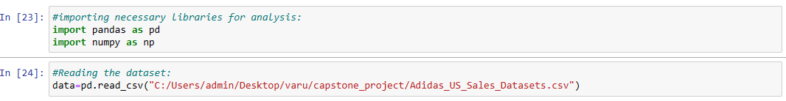 4.2 Preview dataset:



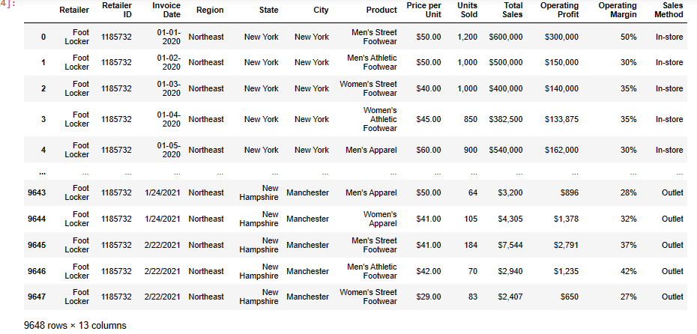

4.3 Cleaning and formatting:

Changing date format:

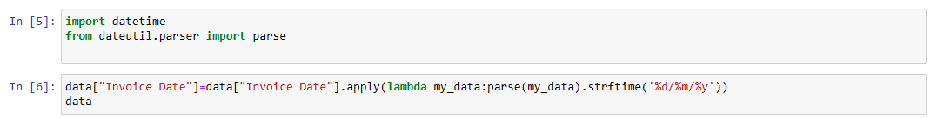

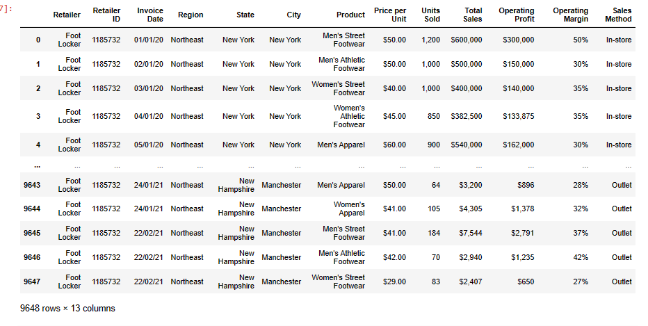Renaming Columns:



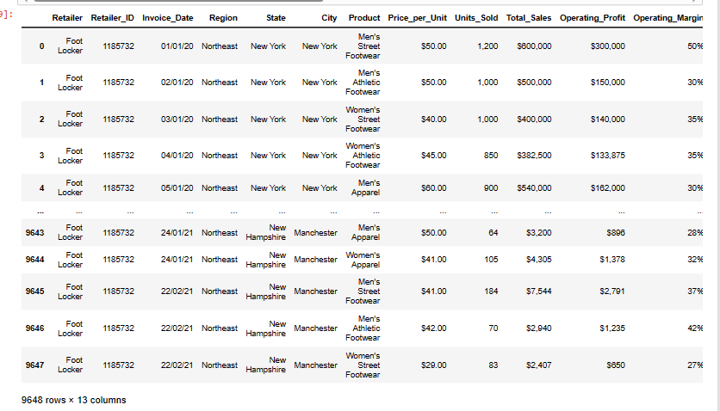Removing Special characters (%, $,”,”) &changing datatype

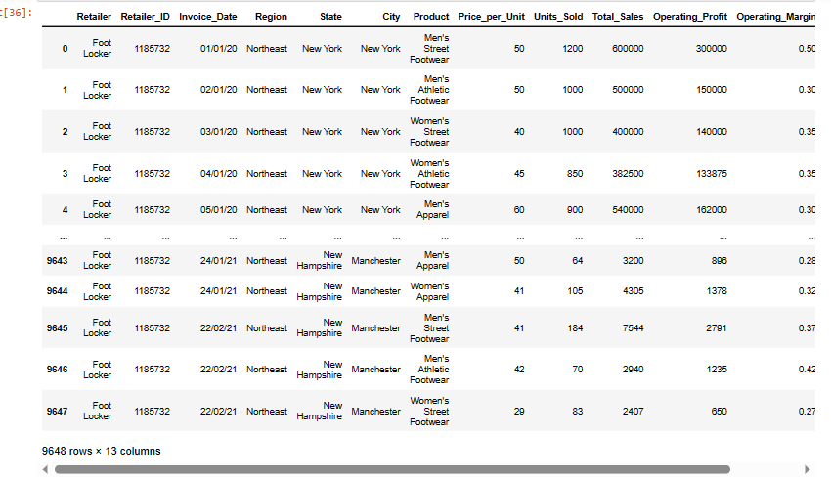Null values:



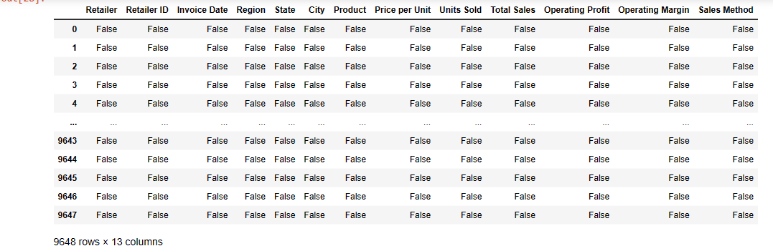Deleting rows:



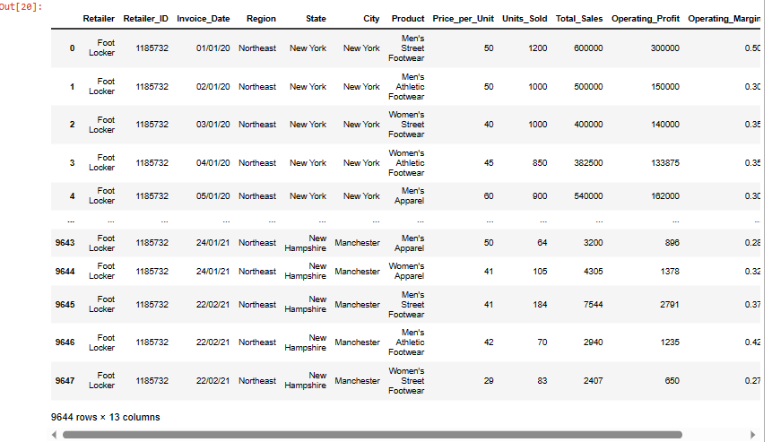

5.Analyse Phase

5.1 Data Manipulation:

Data info:



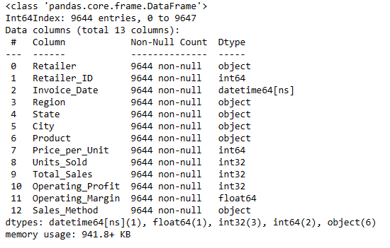

Correlation:



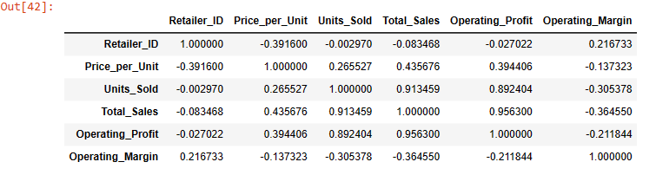Describe:



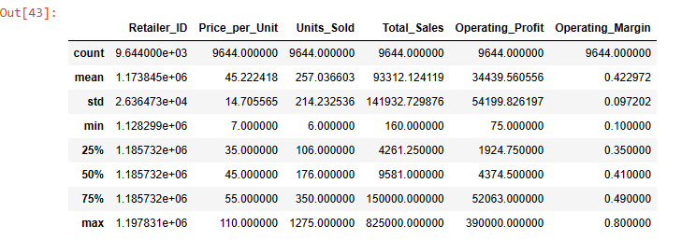Head:



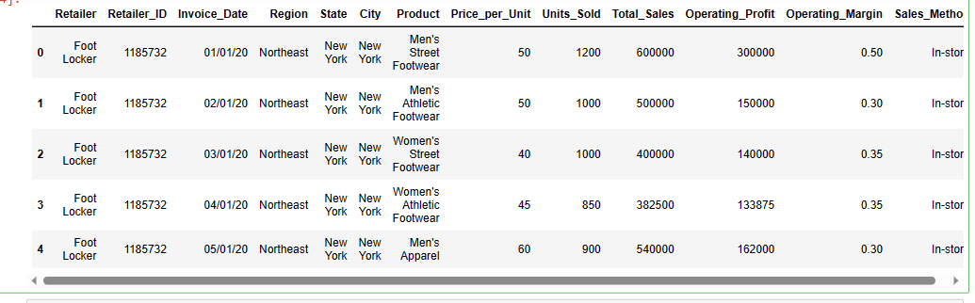

Unique Retailer & Retailer_ID:

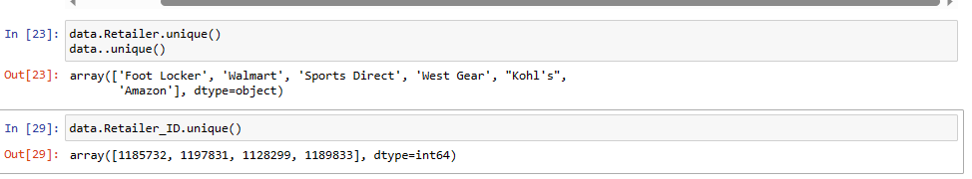

Unique Region, State & City:

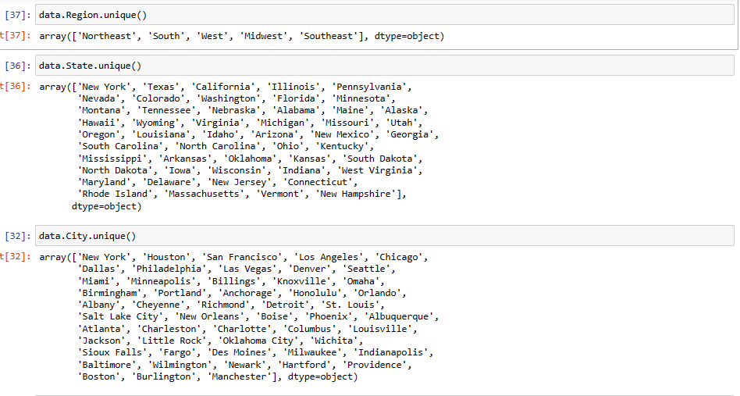

Unique product & Sales_method:

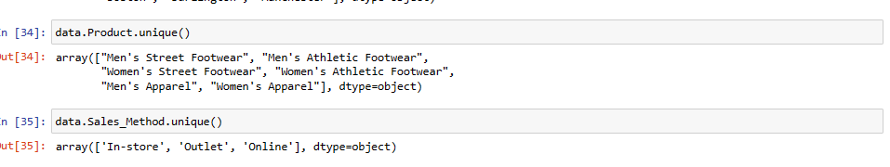

Average of Total_Sales:



Average of price per unit is between 40 to 60

Sorting:

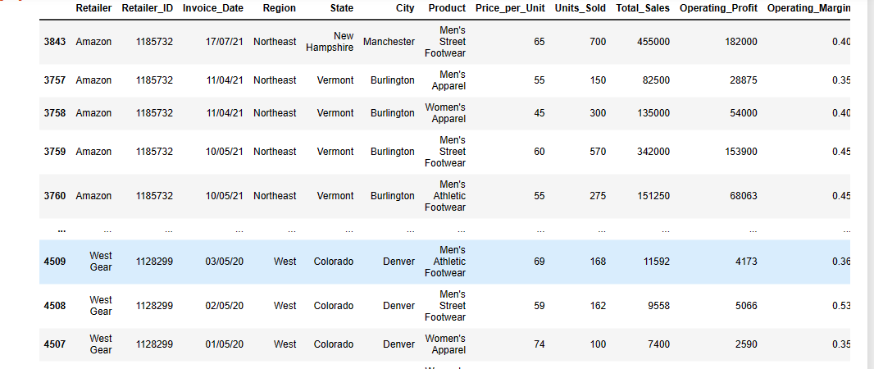

6.Share Phase

6.1 Insights:

1.From US, among 50 States New York has Generated the highest operating Profit (23,329,845) followed by Florida generated Second highest operating profit (20,926,219).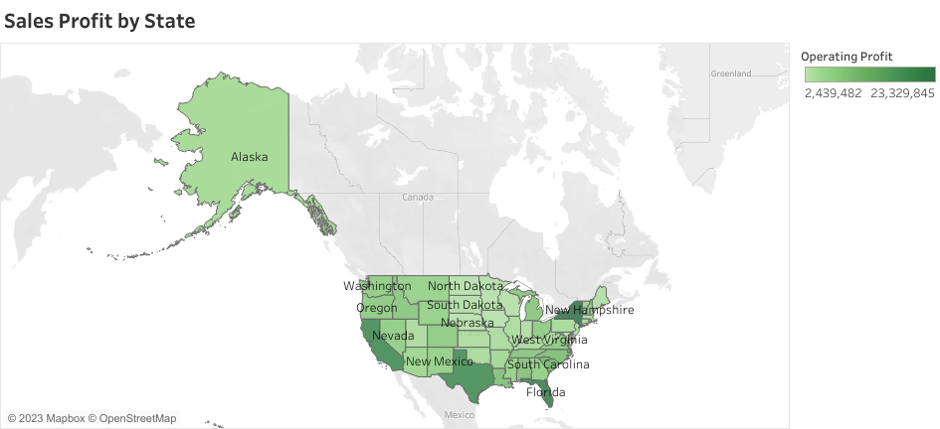

2.Adidas gained more operating margin (2268) by effectiveness of Online Sales method & less operating margin (620) by In-Store Sales Method.

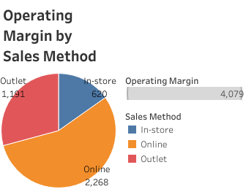

3. From 5 Regions of US West Region has the highest Sharing of Total Sales (269,943,182) & Midwest Region has the lowest sharing of Total Sales (135800459).

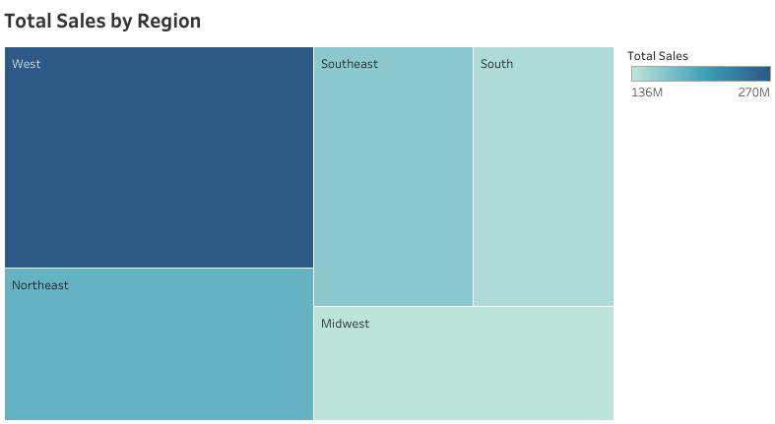

4. From Quarters (Q1, Q2, Q3, Q4) of The years 2020&2021, Q3 has the highest Operating Margin & Units Sold. Q4 has second highest Operating Margin but lowest Unit Sold.

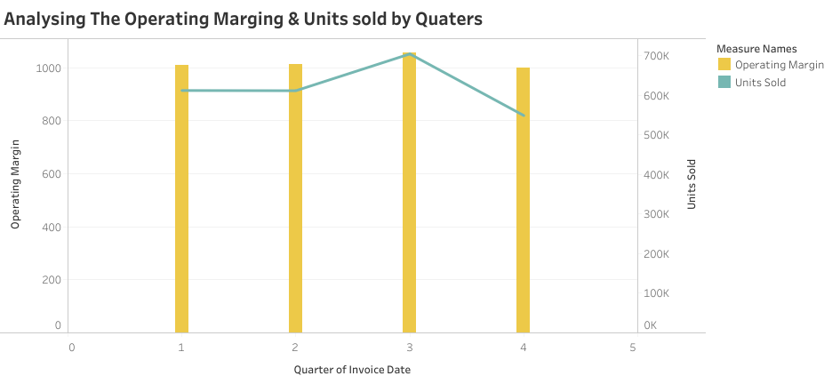

5. From 6 Products of Adidas, Men’s Street Footwear is the Popular product, it has more Units of Sales (593,320) & Women’s Athletic Footwear has less Units of sales (317,236).

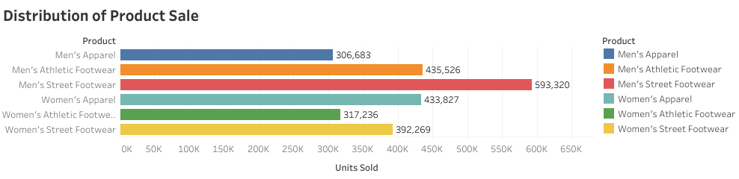

6. West Gear Retailer has the Highest Total Sales& Operating Profit, followed by Foot Locker has the Second Highest Total Sales & Operating Profit.

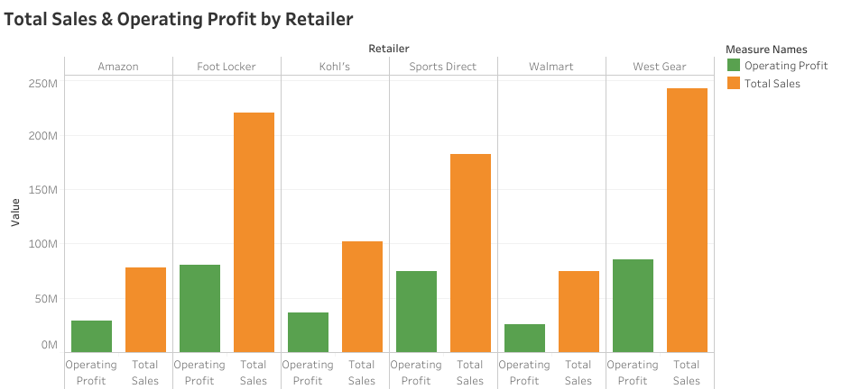

7. By Each Retailer I have founded the relationship between Price per Unit and Units sold, in this (1185732) Retailer ID has Positive relationship & 1189833 has the Negative relationship.

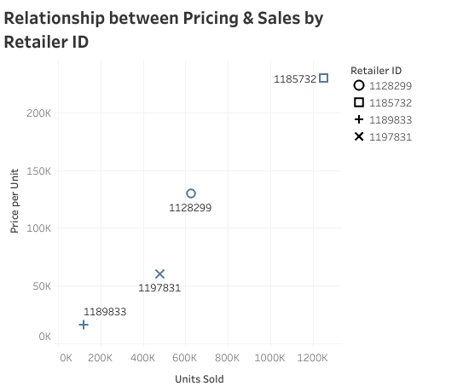

7. Act(Conclusion):

Based on above insights, Adidas can act by implementing targeted marketing strategies in the top-performing regions (West), states (New York), and cities. Adidas can also optimize There pricing strategy based on the popularity of certain products and their impact on sales (Men’s Street Footwear). Additionally, you can collaborate with the most successful retailers (West Gear) & Retailer ID’s (1185732) to further enhance sales and profitability. Lastly, using historical data to forecast future sales can help you make informed business decisions and stay ahead of the competition.

To increase sale in Regions, states, cities with lower performance. It’s important to take a comprehensive approach. Apply the strategies of most successful Regions, States, cities. And for to increase sales of products apply the Pricing strategies, Compare the sales method and their effectiveness to optimize the sales approach.